**Industrial Visit Report**

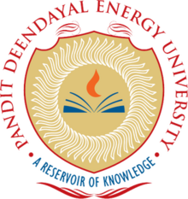

Industrial Visit Report,

Department of Computer Science,

School of Technology,

Pandit Deendayal Energy University

By

Tirth Shah(22BCP230)

Submitted to

Ms. Komal Singh,

Department of Computer Science & Technology

Pandit Deendayal Energy University

Submitted on:

9th August 2024

**Acknowldegements**

I am deeply thankful to the staff at VSSE, eInfochips, and SLTL for their valuable time and informative presentations. My gratitude also extends to Pandit Deendayal Energy University (PDEU) and the School of Technology (SOT) for organizing these industrial visits. These experiences have greatly enhanced my learning, providing a crucial link between academic theory and real-world industry practices, which has been pivotal in my educational growth.

**Introduction**

Pandit Deendayal Energy University (PDEU) arranged a sequence of industrial tours as an integral part of its academic program, aiming to deepen students' comprehension of real-world industrial operations. These excursions were designed to give students hands-on experience, effectively linking the theoretical concepts learned in classrooms with the practical realities of industry. This report aims to encapsulate the key insights and learning outcomes derived from these visits.

**The Importance of Industrial Visits**

Industrial visits are a vital component of PDEU's academic curriculum, providing a key avenue for experiential learning. These visits offer students the opportunity to directly observe how the theories and concepts they learn in class are applied in real-world settings. Through these experiences, students can see industry operations in action, gain an understanding of the challenges professionals encounter, and learn about cutting-edge technologies and practices in the field. Engaging with industry experts during these visits also offers valuable insights that can greatly enhance both their academic understanding and professional skills.

**Industries Visited**

**Industry 1:**

* **Name:** Space Applications Centre (SAC), Indian Space Research Organisation (ISRO)
* **Date of Visit:** 14th October 2023

**Industry 2:**

* **Name:** Einfochips – An Arrow Company
* **Date of Visit:** 12th February 2024

**Industry 3:**

* **Name:** Sahjanand Laser Technology Ltd (SLTL)
* **Date of Visit:** 13th March 2024

**Vikram Sarabhai Space Exhibition (VSSE), Space Applications Centre (SAC),**

**Indian Space Research Organisation (ISRO)**

The Space Applications Centre (SAC) is a premier research and development hub of the Indian Space Research Organisation (ISRO), located in Ahmedabad. Established in 1972, SAC specializes in the development of spaceborne and airborne instruments and payloads.

It plays a pivotal role in ISRO’s missions by providing advanced solutions for communication, navigation, and Earth observation.

With a focus on technological innovation and societal impact, SAC supports a wide range of applications including satellite technology, remote sensing, and space science, contributing significantly to India's space capabilities and global space advancements.

1. **Observation we made during the visit**

**Advanced Satellite Technologies:**  
VSSE has showcased ISRO’s expertise in space technology by developing state-of-the-art communication and observation satellites for various planets and their satellites which are equipped with advanced payloads and sensors.

**State-of-the-Art Research Facilities For The Optical Parts of Satellites:**  
The VSSE showcased ISRO Ahmedabad’s SAC’s research facilities, highlighting the cutting-edge technology and methodologies employed in the development of optical sensor and other optical instruments required for ISRO’s space missions. This included specialized labs for assembly and testing of these optical instruments.

**Interdisciplinary Collaboration:**  
Recognizing the complexity of space technology, SAC emphasized the importance of interdisciplinary collaboration among scientists, engineers, and researchers, fostering innovation and precision in their projects.

1. **Services and Products provided by ISRO SAC**

### ****1. Communication Instruments:****

* **Communication Transponders:**
  + For INSAT and GSAT series satellites, supporting services like VSAT, DTH, internet, broadcasting, and telephony.
* **Navigation Payloads:**
  + For Indian Regional Navigation Satellite System (IRNSS) and GPS Aided Geo Augmented Navigation (GAGAN).

### ****2. Remote Sensing Instruments:****

* **Optical and Microwave Sensors:**
  + Developed for Earth Observation, with applications in agriculture, environment, climate change, and oceanography.
* **Airborne Sensors:**
  + Includes thermal sensors, multispectral scanners, and Side Looking Radar.
* **SAR System:**
  + Airborne Synthetic Aperture Radar systems for high-resolution imaging.

### ****3. Software and Applications:****

* **Signal and Image Processing Software:**
  + For processing satellite data.
* **GIS Software:**
  + For Earth Observation applications.
* **General Circulation Models:**
  + Used for weather and ocean state prediction.

1. **Impact and Market Influence**

The Space Applications Centre (SAC) plays a crucial role in the space technology sector, with significant contributions to satellite technology and space-based applications. SAC's developments enhance India’s capabilities in disaster management, environmental monitoring, communication, and weather forecasting.

The center's technologies support a wide range of applications, from natural disaster response to agricultural productivity improvements, as cost effective solutions making ISRO the global leader in making cost optimized space mission. SAC's innovations have also positioned India as a global leader in space technology, known for its technological excellence and cost-effective solutions.

1. **Exploring SAC's Legacy and Technological Contributions**

I was particularly impressed by the efforts of SAC in developing GIS software, which is widely utilized by engineers worldwide for a variety of scientific purposes.

Additionally, I appreciated the Vikram Sarabhai Space Exhibition, which effectively showcased SAC's journey and their significant contributions over time.

The detailed descriptions provided by the instructors and the informative cards placed throughout the exhibition further enhanced the experience, making it both educational and engaging.

**eInfochips-** **An Arrow Company**

eInfochips, an Arrow Electronics company, is a leading provider of digital transformation and product engineering services.

eInfochips accelerates time to market for its customers with its expertise in IoT, AI/ML, security, sensors, silicon, wireless, cloud, and power.

eInfochips has been recognized as a leader in Engineering R&D services by many top analysts and industry bodies, including Gartner, Zinnov, ISG, IDC, NASSCOM and others.

eInfochips has shown their excellence in the industry by producing more than 500 devices, IPs and other research oriented studies, and having 40 million installations of such products in 140 nations of the world.

1. **Observation we made during the visit**

**Seamless Hardware and Software Integration:**  
Einfochips demonstrated their ability to integrate hardware and software components effectively, resulting in robust and efficient solutions.

**Innovative IoT Devices:**  
There were showcases of IoT devices capable of processing data in real-time and communicating across networks, highlighting their advanced capabilities.

**Advanced AI Algorithms:**  
The application of AI algorithms was observed, showing how they are employed to analyze data and make decisions in real-time.

**Practical Product Demonstrations:**  
The visit included product demos where theoretical knowledge was brought to life through embedded systems, IoT, and AI, offering a practical view of these technologies in action.

**State-of-the-Art Laboratories:**  
The tour provided a look at their modern labs and departments, which showcased the latest advancements in technology and product development.

1. **Services and Products provided by eInfochips**

**AI/ML Services:** Advanced artificial intelligence and machine learning technologies are employed to drive innovation across multiple sectors, offering tailored solutions to meet specific business needs.

A camera is a passive device that requires human analysis to extract insights, which is challenging with vast amounts of video data. As road congestion increases, continuous monitoring by humans is impractical.

eInfochips (An Arrow Company) has solved this issue with deep learning solutions on the NVIDIA® Jetson™ platform. This technology enables real-time traffic detection and offers features like vehicle anomaly detection, parking spot detection, license plate recognition, and more.

**Embedded Systems:** Specialized in the design and integration of embedded systems, the company ensures these systems are highly secure, reliable, and adaptable for diverse industries, safeguarding both devices and data effectively.

eInfochips, a Qualcomm Technology Partner, assisted an American consumer robotics company in enhancing firmware for their robot vacuum cleaners, originally based on the Qualcomm Snapdragon 212 processor.

The project involved adding Wi-Fi and Bluetooth connectivity for remote control and mobile app integration. Additionally, eInfochips supported the design of the next-generation product using the Qualcomm QCS404 processor, ensuring compatibility with future innovations.

**Sensor Technology:** Cutting-edge sensor technology is developed and deployed, facilitating precise data acquisition and real-time monitoring across a wide range of applications.

**Wireless Solutions:** Innovative wireless communication solutions are provided, optimizing data transfer and connectivity in various environments, enhancing both efficiency and reliability.

**Cloud Services:** The company offers robust cloud integration and services, improving data accessibility and management while ensuring scalable and secure cloud-based infrastructures.

**Power Management:** Focused on efficient power utilization, the company provides solutions that enhance power management and control, ensuring energy efficiency and sustainability in operations.

1. **Impact and Market Influence**

eInfochips, an Arrow firm, is a leading global provider of semiconductor design and product engineering services.

With over 500 devices developed and 40 million installations across 140 countries, eInfochips is renowned for its technical innovation.

The company excels in IoT, AI/ML, security, sensors, wireless, cloud, and power technologies, helping clients bring products to market faster.

eInfochips is crucial in the tech industry for its role in accelerating product development across various sectors.

Its comprehensive engineering services have earned recognition from top industry analysts and organizations, including Gartner, Zinnov, ISG, IDC, and Nasscom, for its commitment to quality and innovation.

1. **Exploring SAC's Legacy and Technological Contributions**

I was particularly impressed by eInfochips' services and products, especially their advancements in AI and embedded systems.

Additionally, I appreciated how they managed their team resources effectively to develop interdisciplinary products and deliver them on time.

The exhibition of their products and the detailed explanations provided by the instructors further enriched the experience, making it both informative and engaging.

**Sahjanand Laser Technology Ltd (SLTL)**

Sahajanand Laser Technology Limited (SLTL) is dedicated to bringing advanced technology to both small and large-scale industries.

Renowned for its cost-effective and precise laser cutting and engraving solutions, SLTL caters to a diverse range of sectors, including diamond processing and high-tech electronics.

As a market leader in CNC laser solutions, SLTL’s innovations are pivotal in driving the evolution of smart factories and various other industries.

With a focus on making technology accessible and future-proof, SLTL continues to play a key role in enhancing industrial efficiency and capabilities worldwide.

1. **Observation we made during the visit**

**Advanced Laser Systems**: SLTL employs cutting-edge laser technologies, including fibre, CO2, and UV lasers, each designed for specific applications with high precision and efficiency.

**Automated Manufacturing Line**: The company utilizes advanced robotics and control systems for a fully automated production line, ensuring consistent quality and high manufacturing standards.

**Creative R&D Methods**: SLTL’s R&D department focuses on continuous innovation, developing new technologies and enhancing existing ones to meet evolving market demands.

**Integrated Solutions**: They offer comprehensive laser solutions by combining software and hardware, delivering customized applications to meet diverse client requirements.

1. **Services and Products provided by eInfochips**

**Laser Cutting Systems**: SLTL provides precise laser cutting devices for both metal and non-metal materials, suitable for a range of industries needing detailed and complex cuts.

**Laser Engraving Solutions**: Their systems are designed for etching patterns and text on various materials, including ceramics and metals, ideal for personalized branding and marking.

**Permanent Marking Solutions**: SLTL’s laser marking equipment ensures durable and clear markings for traceability, identity, and aesthetic purposes.

**Laser Welding Machines**: They offer advanced equipment for accurate and efficient welding of metal components, suitable for both production and repair applications.

1. **Impact and Market Influence**

**SLTL** is a leading force in the laser technology sector, providing innovative solutions that enhance quality and efficiency across multiple industries.

Their products find applications in consumer goods, electronics, automotive, and aerospace, contributing to high standards of precision, improved product aesthetics, and streamlined manufacturing processes.

SLTL’s reputation in the industry is built on their commitment to technological innovation and customer satisfaction.

1. **Exploring SAC's Legacy and Technological Contributions**

I greatly appreciated that SLTL developed in-house software for their advanced machines, showcasing their commitment to innovation.

It was impressive to see their presence across diverse industrial applications, from defense to diamond cutting.

Additionally, the instructors provided thorough and insightful guidance throughout the visit, enhancing the overall experience.

**References**

ISRO : [Space Applications Centre (SAC) (isro.gov.in)](https://www.isro.gov.in/SAC.html)

Einfochips: [Product Engineering Services | Digital Transformation - IoT, ML, and Cloud Solutions (einfochips.com)](https://www.einfochips.com/)

SLTL: [Home | SMT (smtpl.com)](https://smtpl.com/)

**Appendices**

**ISRO-SAC-VSSE**

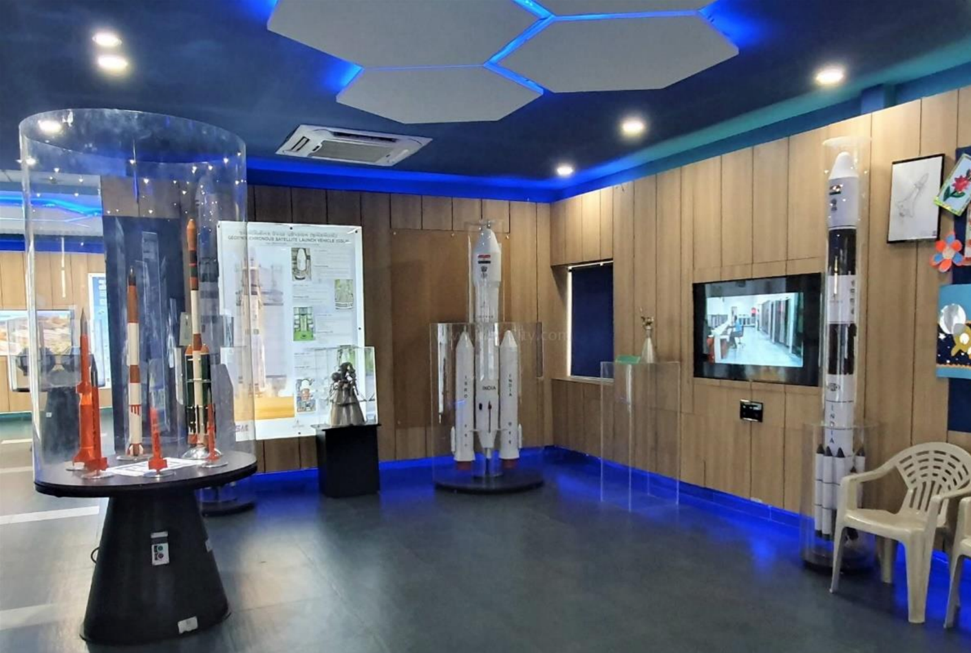

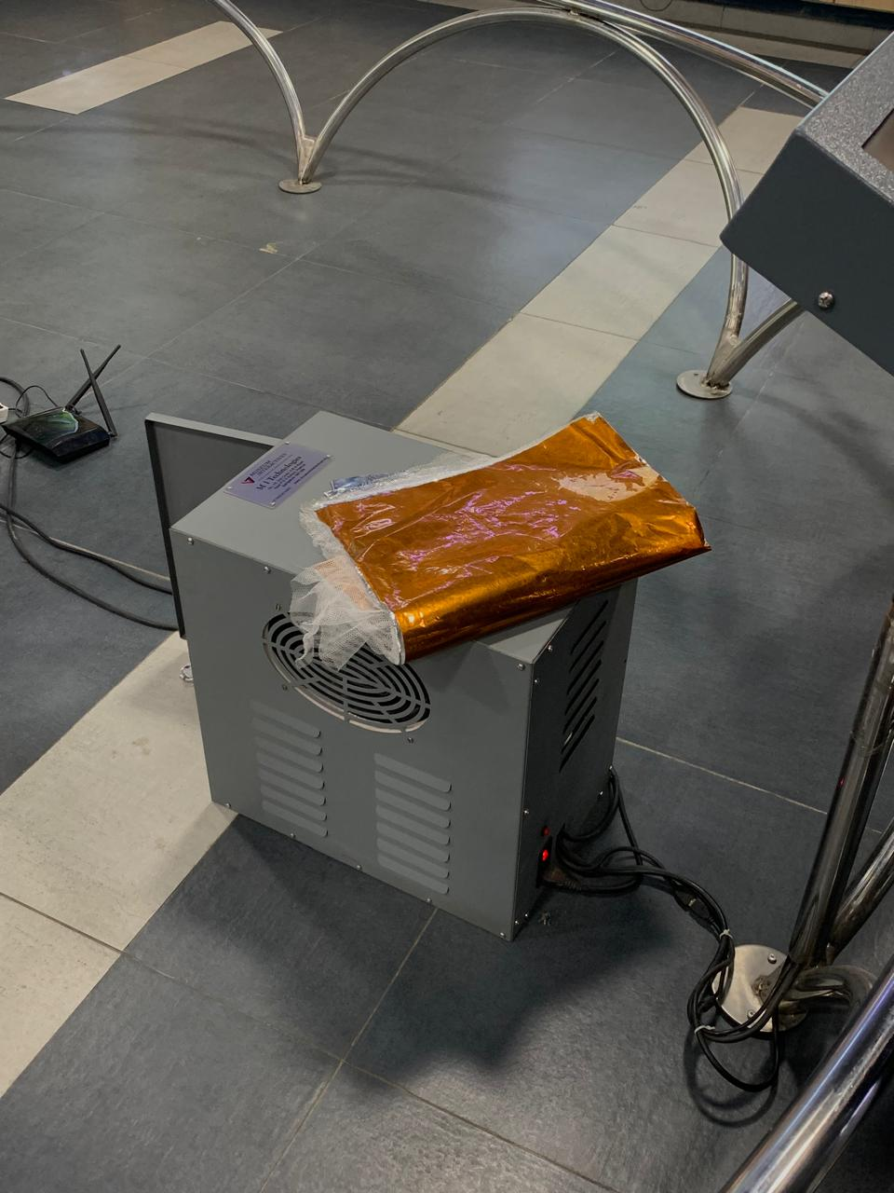 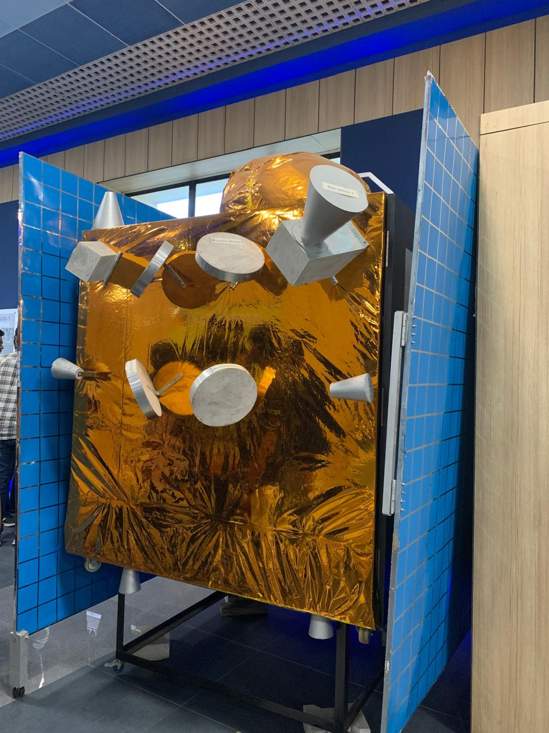

**e-Infochips**

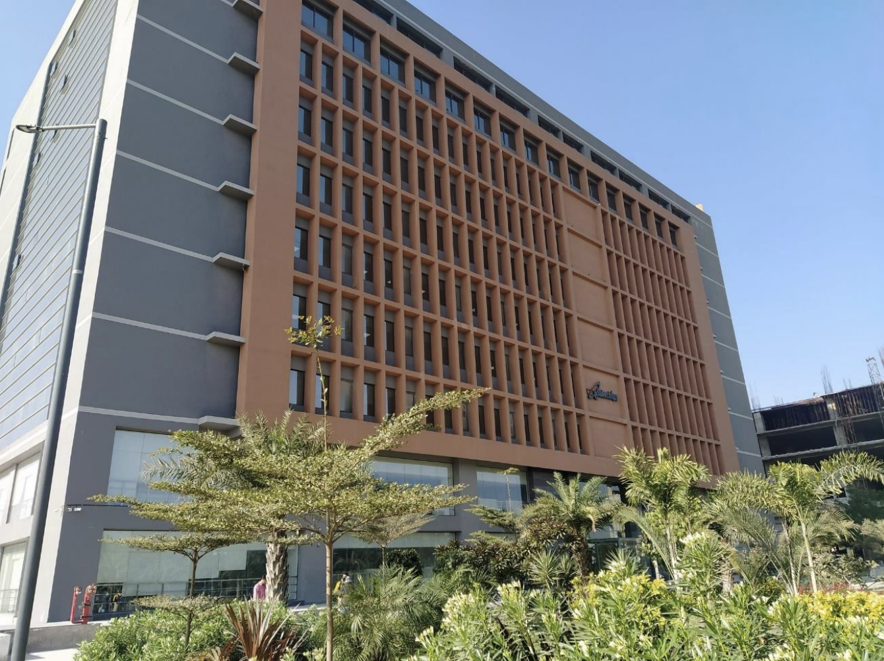

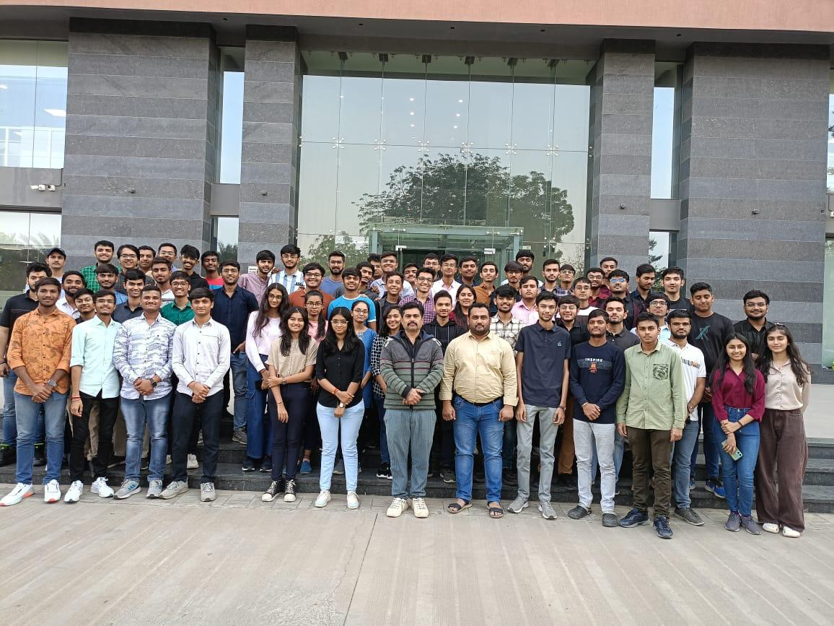

**SLTL**

